Deleting Employees
When an employee leaves the bank, they should be deleted from the system. Here are the steps to do that:
- Click the "Employees" icon in the ribbon
- Choose the employee's Department/Branch from the dropdown
- Select the employee name
- Click [Delete Employee]
- Click [Yes] to confirm the deletion
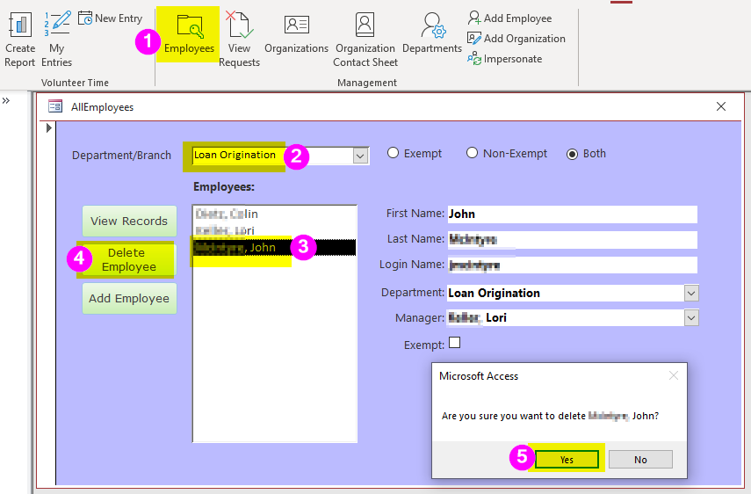

Un-Deleting Employees
When an employee is "deleted", we don’t actually remove their employee record. Rather, we fill in the date and time the employee was marked as deleted in the system and who deleted them. Once they are marked as deleted, they are hidden from most forms. However, their data remains in the system for historical purposes.
There is currently no user interface in the program to allow you to "un-delete" an employee once they have been deleted. If an employee is accidentally deleted—or if they leave and come back to the bank—that's when you would need us to intervene to restore their deleted record.

Notes
- Only certain admin users have permission to delete employees; if you do not see the [Delete Employee] button, you will need to ask someone with that permission to perform the delete for you
- Do not use the [Delete Employee] button if the employee is moving to a new department
- There is no way to "Un-Delete" an employee within the system; if you accidentally delete an employee, contact us (Grandjean & Braverman) to restore the deleted employee
- If you delete an employee from the system, you cannot re-add that employee back into the system; the system only allows one employee record per Windows login name
- Do not try to get around the one-employee-per-login restriction by adding an employee record with a different login than what IT has assigned them; the program will not work without the user's actual login name

