Tax Claim Return

Running the Report
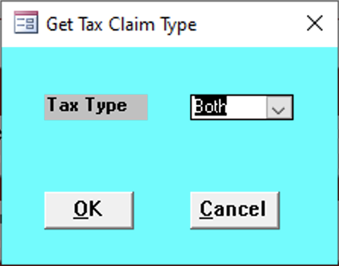

Tax Type
Select the type of tax of the report.
- Municipal
- School
- Both

Report Contents
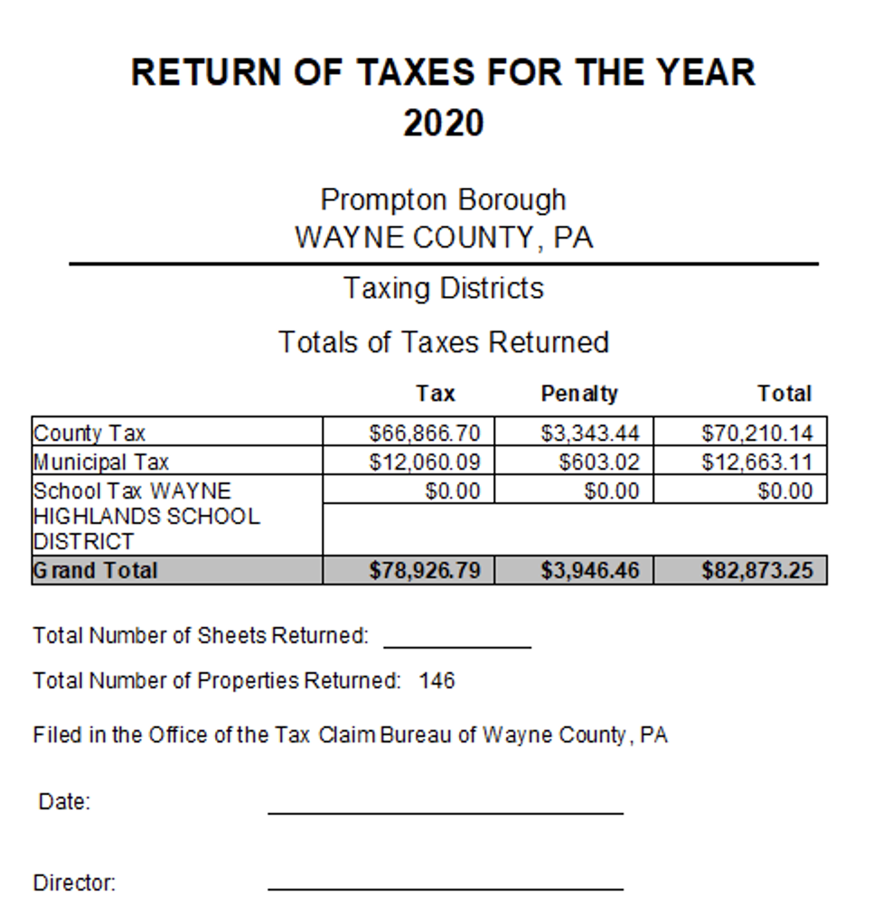
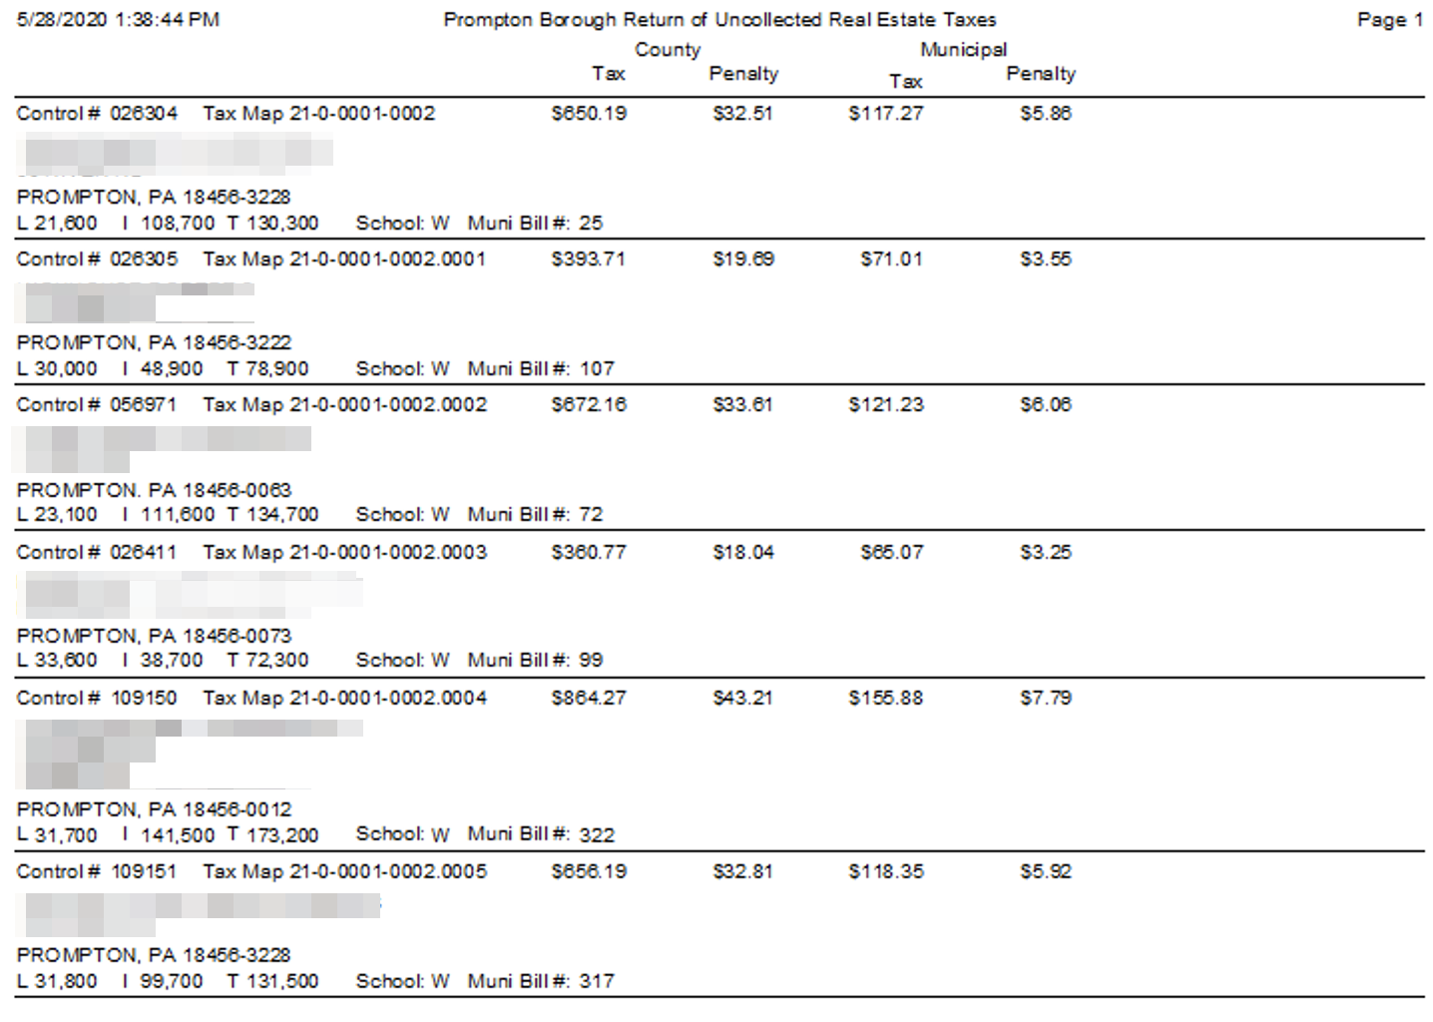

Tax
Type of tax on the report.

Penalty
How much of a fee has been applied.

Total
Total sum of all amounts.

