Return Report

Running the Report
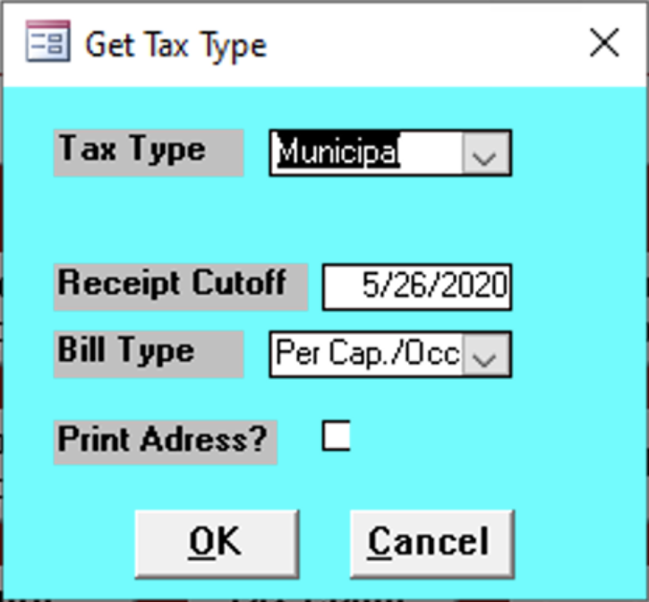

Tax Type
Enter the tax type of the reports.
- Municipal
- School

Bill Type
Select the type of bill of the report

Receipt Cutoff
Enter the final date of the reports needed.

Print Address
Check this box to print addresses; leave unchecked to not print any.

Report Contents
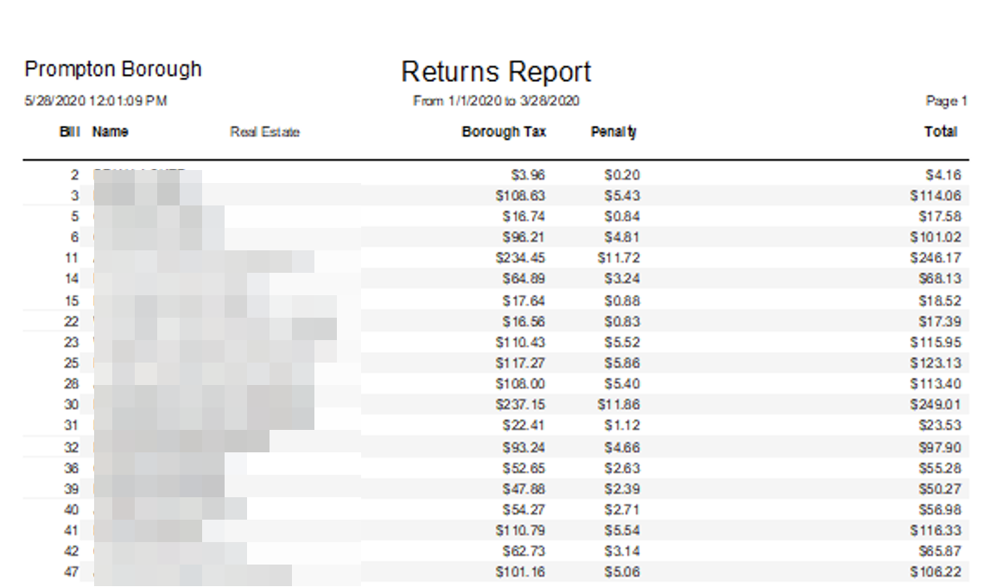

Bill
Bill number.

Name
Name of the client.

Real Estate
todo

Borough Tax
todo

Penalty
todo

Total
Sum of all values.

