Return Report
=====Running the Report
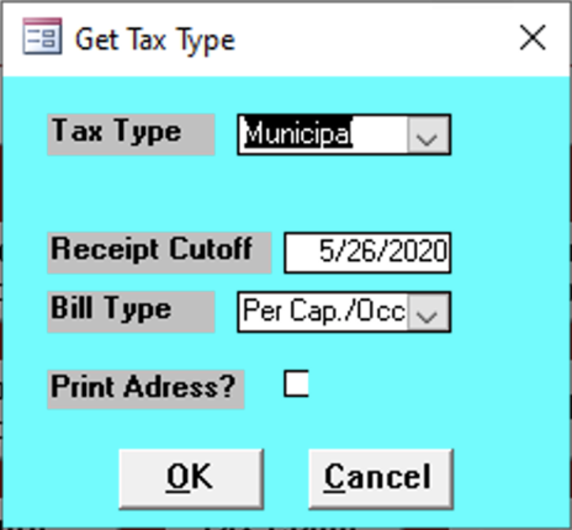

Tax Type
Enter the tax type of the reports.

Receipt Cutoff
Enter the final date of the reports needed.

Bill Type
Select the type of bill of the report

Print Address
Check this box to print addresses; leave unchecked to not print any.

Report Contents
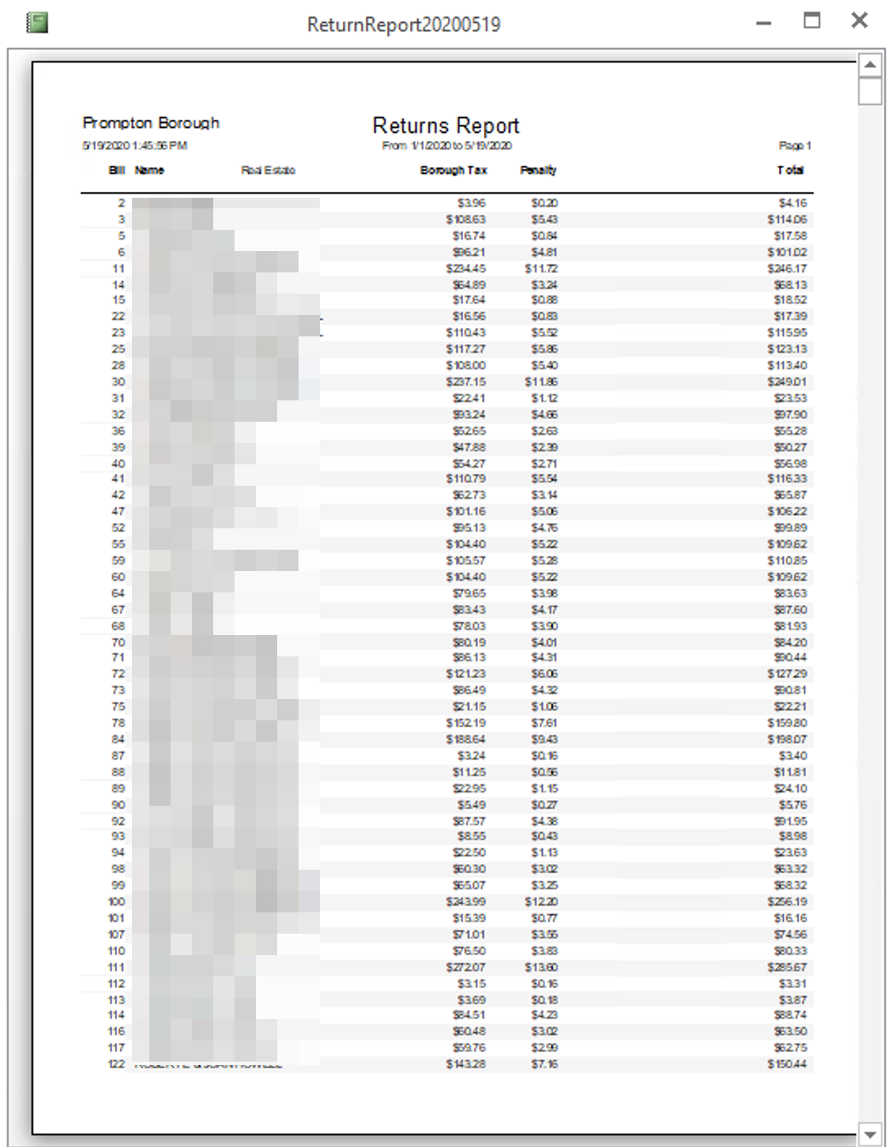

Bill
todo

Name
Name of the client.

Real Estate
todo

Borough Tax
todo

Penalty
todo

Total
Total of all values.

