Return Report
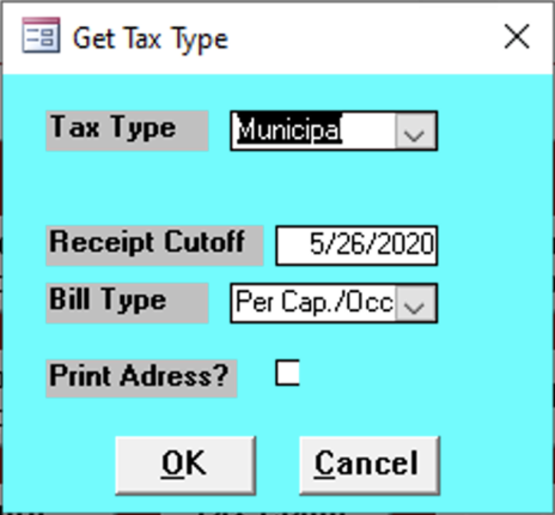

Tax Type
Enter the type of tax of the reports needed.

Receipt Cutoff
Enter the date of the last receipt needed.

Bill Type
Enter the type of bill.

Print Address
Check the box to print the address.

