Receipt Labels

Running the Report
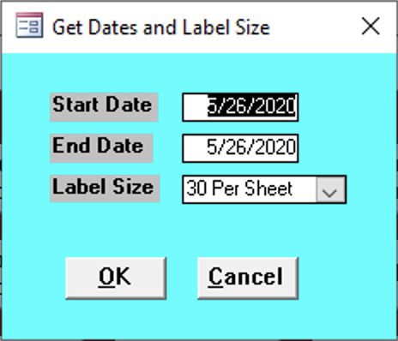

Start Date
Enter the start date for the reports needed.

End Date
Enter the end date for the reports needed.

Label Size
Select how many labels per page.
- 30 Per Sheet
- 80 Per Sheet

Report Contents
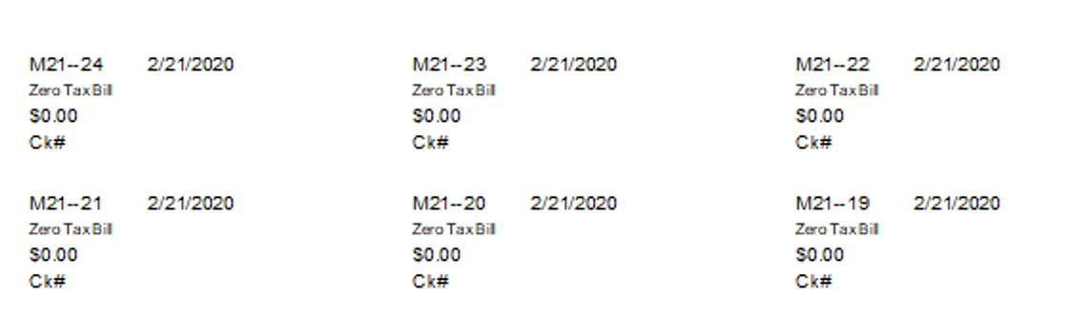
todo Not sure what each value stands for

