New Bill Report
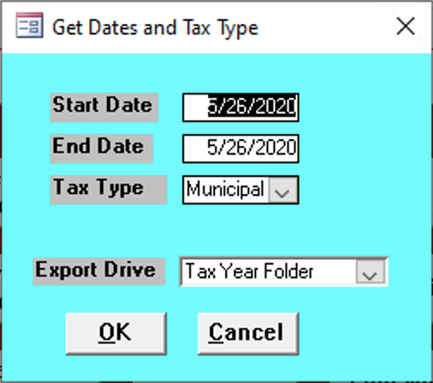

Start Date
Enter the start date of the reports needed.

End Date
Enter the end date of the reports needed.

Tax Type
Enter the tax type fo the reports needed.

Export Drive
Input the place on your computer where the exports should go

