Mort Co Report

Running the Report
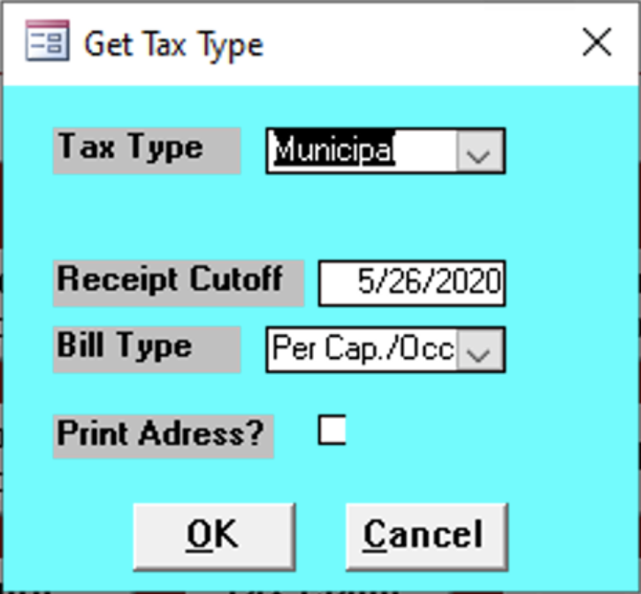

Mort Co
todo

Tax Type
Enter the tax type of the reports.
- Municipal
- School

Report Contents
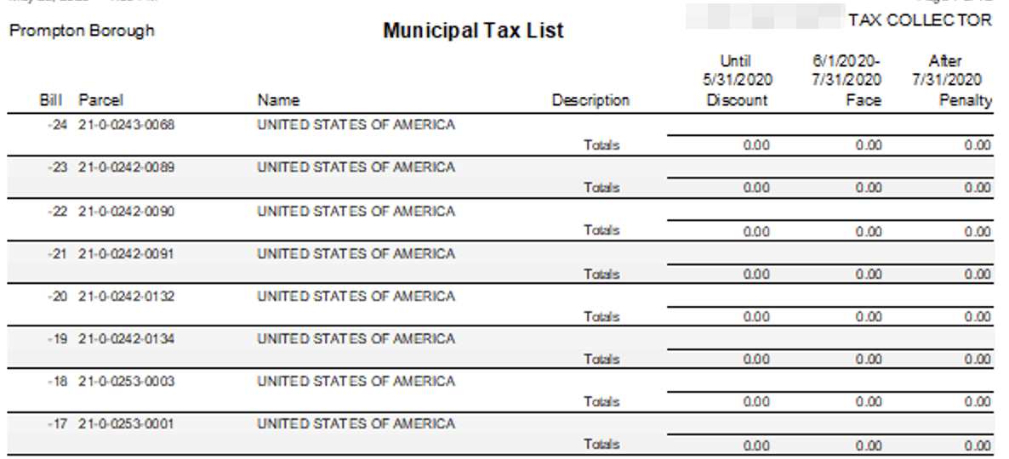

Bill
Bill Number

Parcel
todo

Name
todo

Description
todo

Discount
todo

Face
todo

Penalty
todo

