Monthly Report

Running the Report
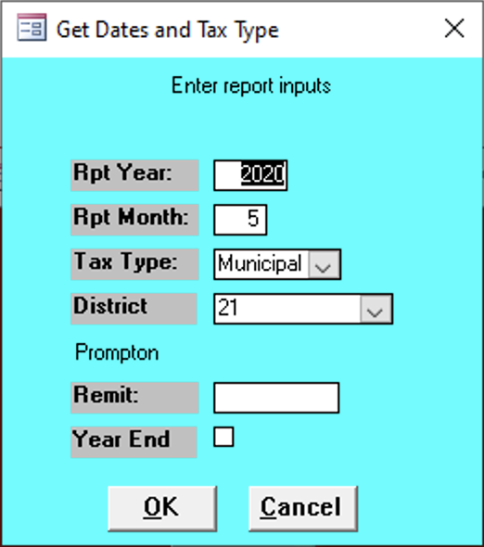

Rpt Year
Enter Report Year

Rpt Month
Enter Report Month

Tax Type
Enter the Tax Type of the report.

District
Enter your district.

Remit
todo

Year End
todo

Report Contents
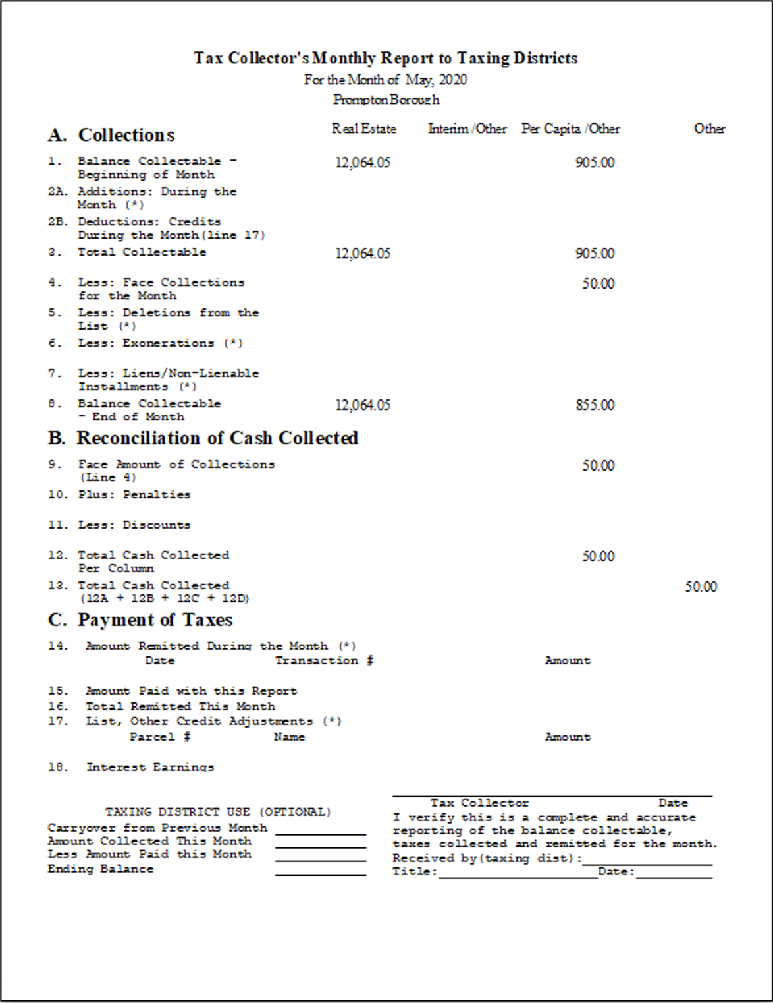

Real Estate
todo

Interim/Other
todo

Per Capita/Other
todo

Other
todo

