Ledger Form
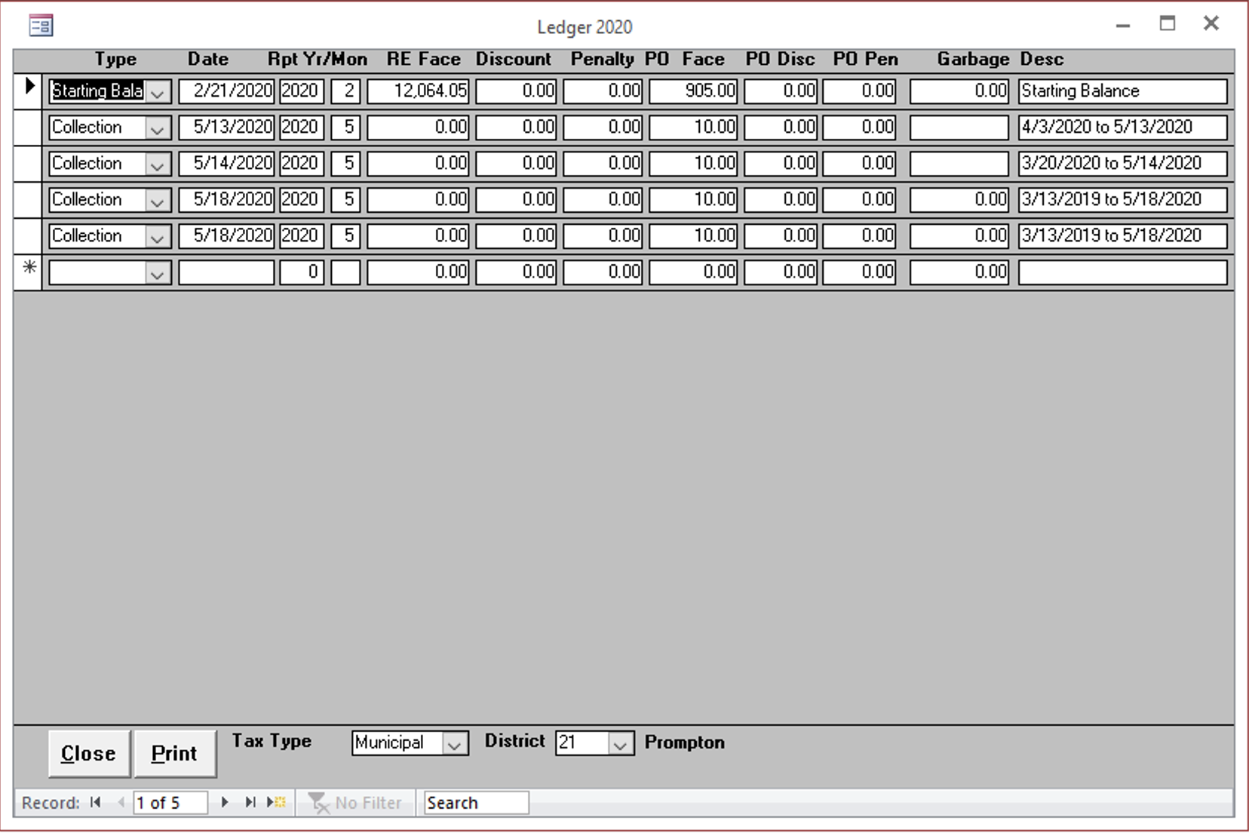

Type
Enter type of record.

Date
Enter the current date.

Report Year
Enter the year of the report.

Report Month
Enter the month of the report.

RE Face
todo

Discount
todo

Penalty
todo

PO Face
todo

PO Disc
todo

PO Pen
todo

Garbage
todo

Desc
todo

