PDF Creator
Here are the steps to install PDF Creator:
- Click this link to download the setup file: https://grandjean.net/updates/PDFCreator-3_2_0-Setup.exe
  - Choose "Run" or "Open" if given the option when downloading the file above
  - If that's not an option, double-click on the file after it finishes downloading
- Windows will ask if you want to allow the program to make changes to your computer. Click [Yes]:
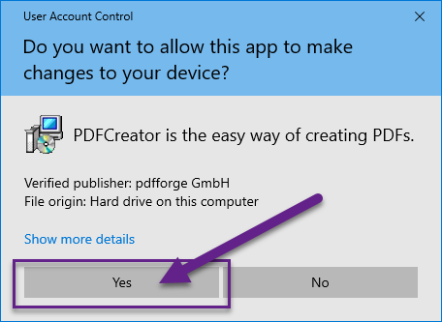
- Click [OK] to proceed with "English" as the setup language:
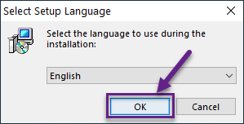
- Click [No] when offered to download the new version of PDF Creator
  - Note: The TaxColl2k program is fully compatible with the latest version of PDF Creator. However, the installer for the new version of PDF Creator makes it hard to avoid installing unnecessary 3rd-party software.
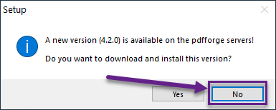
- Click [Next] on the Welcome screen:
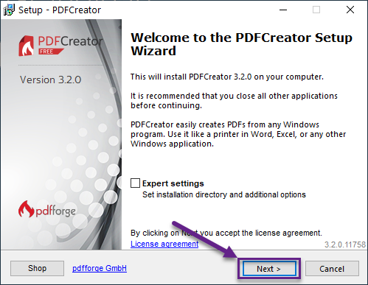
- Uncheck the box next to [ ] PDF Architect 6 then click [Next >]:
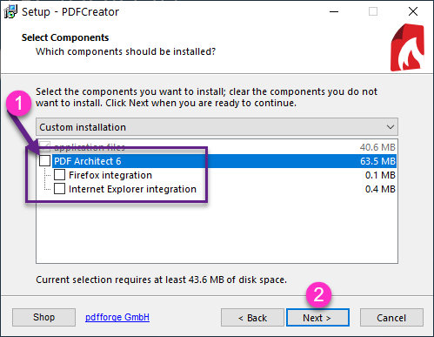
- Click [Install] to complete the installation:


