Download Municipal Data Files (spring bills)
- Click [Utilities] on the Main Menu
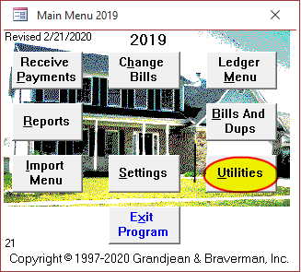
- Click [Get Data Files] button on the Utilities Menu
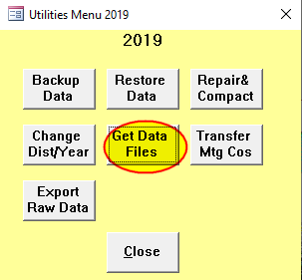
- Click [OK] to download the data file
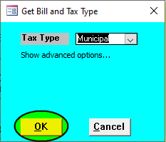
  - If the download succeeds, you should see a message that the file "Myyyyxx.MDB" successfully downloaded to your data directory:
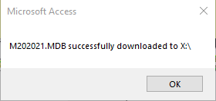
  - If the download fails, you will see a message to that effect. Most likely, this means that the data file is not yet available for download.
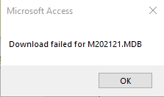
- If the download succeeded, click [Change Dist/Year] to switch to the new file:
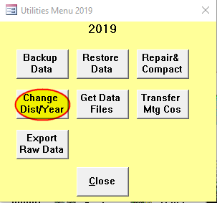
- Enter the Year of the new data file then click [OK] to switch to it:


