Get Sale Type
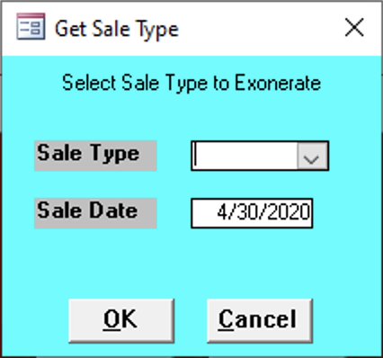

Sale Type
Enter the type of sale for the bills.
- Judicial
- Repository

Sale Date
Enter the date of the sale for the bills.

