Get Dates
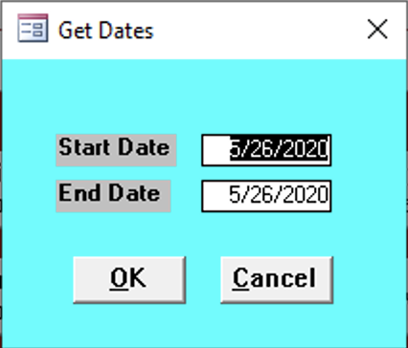

Start Date
Enter the start date for the reports needed.

End Date
Enter the end date for the reports needed.

Import Drive
Select the drive that will be used to import bills.
- Tax Year Folder
- Download
- C

