Get Dates and Label Size
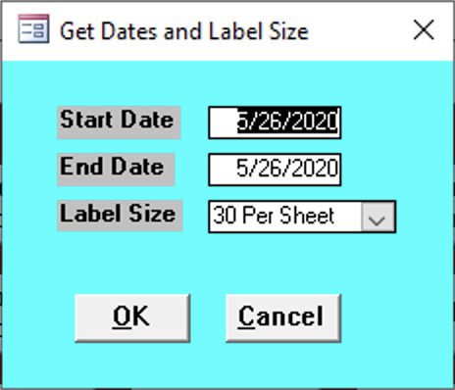

Start Date
Enter the start date for the reports needed.

End Date
Enter the end date for the reports needed.

Label Size
Select how many labels per page.
- 30 Per Sheet
- 80 Per Sheet

