Export Report

Running the Report
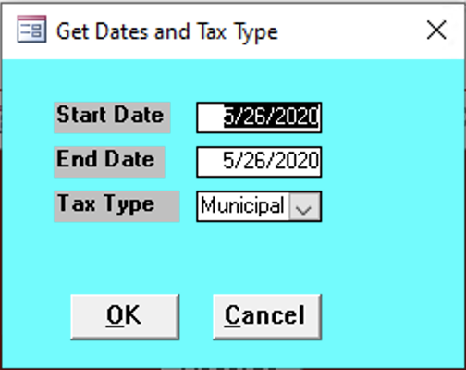
This form appears when you run the Distribution Report and Export Report.

Start Date
Enter the start date for the records needed.

End Date
Enter the end date for the records needed.

Tax Type
Enter the tax type of the records needed:
- County
- Municipal
- School

Export Drive
Enter a location for files to be exported to.
- Tax Year Report
- C

Report Contents
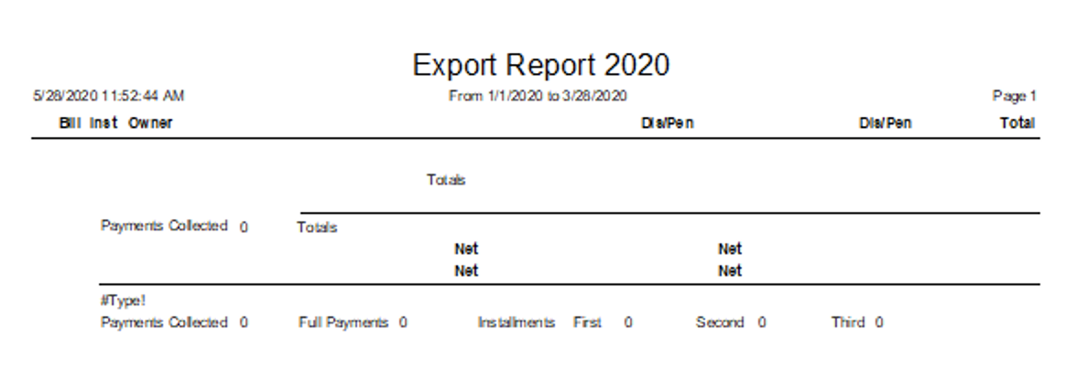

Bill
todo

Inst
todo

Owner
Owner name

Per Capita
todo

Dis/Pen
todo

Occup.
todo

Dis/Pen
todo

Total
Total of all values.

