Exoneration Requests

Running the Report
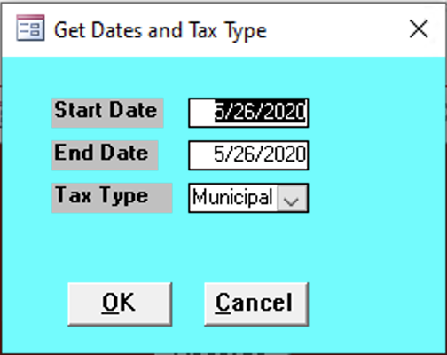

Start Date
Enter the start date for the records needed.

End Date
Enter the end date for the records needed.

Tax Type
Enter the tax type of the records needed:
- County
- Municipal
- School

Exclude if Exempt
todo

Report Contents
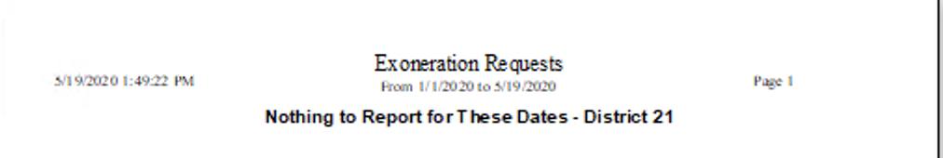
todo could not generate a picture with information

