Collection Totals
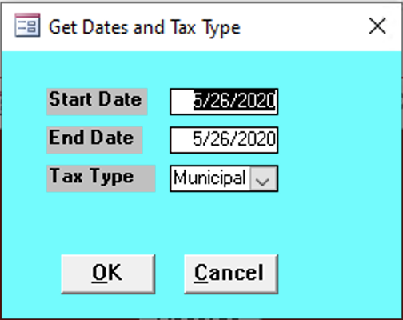

Start Date
Enter the start date for the records needed.

End Date
Enter the end date for the records needed.

Tax Type
Enter the tax type of the records needed:
- County
- Municipal
- School


