Misc Changes Form
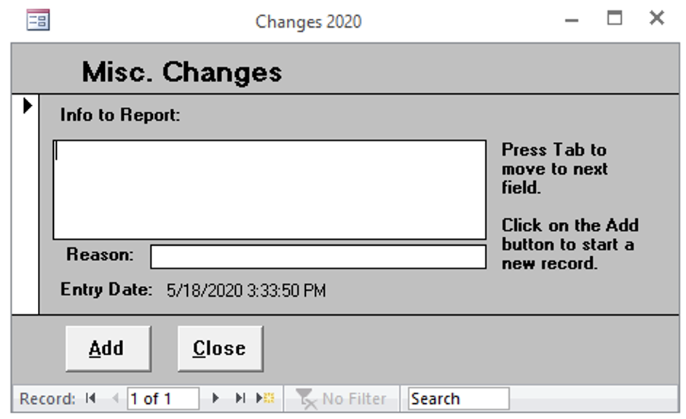

Info to Report
Area to include information to be reported.

Reason
Reasoning to why information was reported.

