Report Styles Feature
The Report Styles feature provides flexibility and customization options for generating Presentence Investigation (PSI) reports. By allowing users to select and modify report styles, the software ensures that each PSI report meets the specific requirements of the case and aligns with the preferences of the court. This wiki page explores the key characteristics and functionalities of the Report Styles feature.

Key Characteristics

Choosing and Changing Report Styles
When creating a new PSI, users have the option to choose a report style from a selection of predefined styles. These styles, such as Full or Abridged, serve as templates that determine the visibility of subsections within the report. Furthermore, users can also change the report style for a PSI at any time, providing the flexibility to adapt the report format as needed.
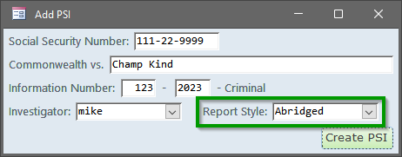

Visibility Settings for Subsections
Each report style has default visibility settings for subsections within a PSI. These settings determine which sections are initially visible and which sections are hidden. The default visibility settings ensure consistency and streamline the report generation process. However, the software allows users to customize the visibility of subsections for each individual PSI, deviating from the default settings when necessary to address the specific requirements of the case.
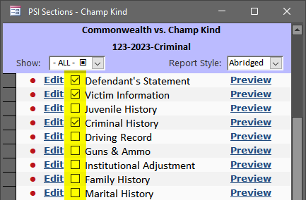

Status Shortcut Menu and Priority of N/A
Each subsection has a status of "Complete", "Incomplete", "Unedited", and "N/A" to indicate whether they have been filled in.
- Complete: all data has been entered for this subsection
- Incomplete: some data has been entered, but some required data is still missing (e.g., may be waiting on the client for information)
- Unedited: no data has been entered (this is the initial setting for every subsection of a new PSI)
- N/A: this subsection does not apply for this particular PSI (e.g., the DUI section for non-DUI cases)
If a subsection is marked "N/A" then a line gets drawn through the section description and it is hidden on the PSI regardless of whether the Visible checkbox is checked. In other words, "N/A" takes priority over the visible checkbox. The status setting can be changed at the bottom of each edit form OR by right-clicking on the status area and choosing a new status from the shortcut menu.
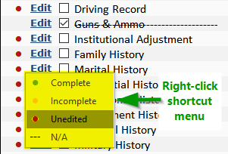

Customization of Default Visibility Settings
Users with the proper permissions can modify the default visibility settings for each report style. This capability allows administrators or authorized personnel to define which sections should be visible by default for each style. By tailoring the default visibility settings, the software empowers the probation department to establish standardized report formats that meet their specific needs and align with the expectations of the court.
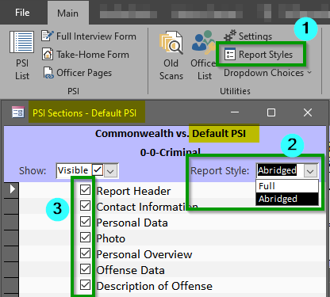

Investigation Detail Form and Section Visibility
By default, only the visible sections of a PSI report appear on the Investigation Detail form. However, the software provides a dropdown menu that allows users to selectively display hidden sections or view all sections (both visible and hidden). This feature enables probation officers to access and review the complete PSI report, including sections that may not be visible by default, providing a comprehensive and detailed overview of the investigation.
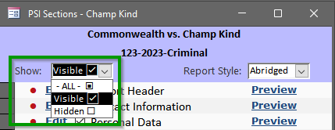

Switching Report Styles in the Investigation Detail Form
To facilitate easy switching between different report styles, the Investigation Detail form includes a dropdown menu. Users can easily change the current PSI report style, allowing them to quickly adapt the view and presentation of the report as needed. This functionality ensures efficient navigation and customization of report styles within the software.
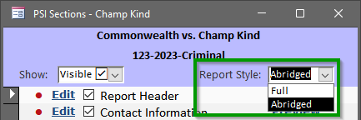

Adding New Report Styles
While users cannot add new report styles themselves, the software developers at Grandjean & Braverman (G&B) can easily incorporate additional styles upon request. For instance, if a particular case type, such as DUI (Driving Under the Influence), requires a specific report style, the developers can create a custom style to cater to those requirements. This flexibility ensures that the software remains adaptable to evolving needs within the probation department.

Conclusion
The Report Styles feature in the Probation application offers probation officers in Wayne County, PA, the ability to select, modify, and customize report styles for PSI reports. With options to choose and change report styles, customize visibility settings for subsections, and easily switch between styles within the Investigation Detail form, the software empowers users to generate reports that accurately reflect the specific requirements of each case. The ability to add new report styles upon request ensures ongoing adaptability to evolving needs, providing a comprehensive and customizable solution for presentence investigations.

