User Security Report
%fineprint{requires Administrator Role}%
Lists all the users and their assigned roles.

Sample Report
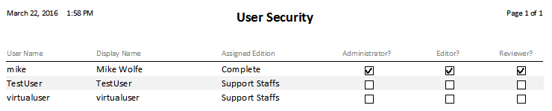

Fields

User Name
The Windows login name of the user. This is the name the user uses to log on to their computer.
%fineprint{Appears in: Users Form, User Security Report}%

Display Name
The user's name as it should be displayed on reports. Generally, it is the user's first and last name. For example, "John Smith".
%fineprint{Appears in: Users Form, Review by User Report, Review by Policy Report, User Security Report}%

Edition
Default edition for the user. New users are assigned the "Complete" edition by default.
%fineprint{Appears in: Users Form, User Security Report}%

Administrator?
This box is checked if the user should have the role of an Administrator.
%fineprint{Appears in: Users Form, User Security Report}%

Editor?
This box is checked if the user should have the role of an Editor.
%fineprint{Appears in: Users Form, User Security Report}%

Reviewer?
This box is checked if the user should have the role of a Reviewer.
%fineprint{Appears in: Users Form, User Security Report}%

