Table of Contents Form
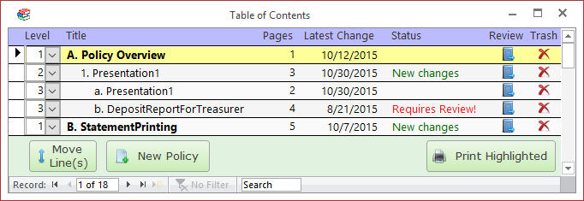

Columns

Title

Pages

Latest Change

Status

Review

Move Line button
Click on this button to move the highlighted line (or lines) to a new location. To move a group of lines, left-click and drag on the record selector boxes on the far left side of the form.

New Policy button
Click on this button to import a new policy document.

Print Highlighted button
Click on this button to send the currently selected policy document to the default printer. If there is no source document (i.e., this is a placeholder line), then the Placeholder Report will print instead. The program will ask you to confirm before sending to the printer.

