Edit Edition Form
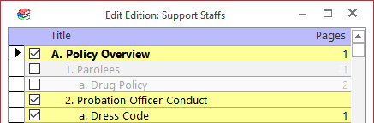
Check the box next to each policy to toggle whether it is included in the edition being edited.
Included policies have check marks in their boxes. They are also highlighted in yellow.
The outline lettering and numbering on this screen reflects the lettering and numbering for the "Complete" edition. The lettering and numbering is automatically updated on the table of contents form and report when other editions are shown there.

