Billing Municipal Tax Collectors
There is a how-to video available for this process at: Creating Spring Invoices for Tax Collectors

Billing for Muni/School Collectors
Tax collectors who collect for both municipal and school owe $800 per year (for 2022 - 2025 tax years).
When creating an invoice, check to make sure the following are set for these collectors:
- Email BCC: ad4da538.grandjean.net@amer.teams.ms
- Credit card payments: ON
- Tags: TaxColl2k Customer
- Service date: 3/1/{yyyy} Ensure this matches the current year
- Description: Municipal data preparation, program updates, and technical support
- Rate: $400
- Message on invoice: Since you collect taxes for both municipal and school, the annual cost for technical support, data conversion, and program updates is $800. This is billed in two installments: $400 after preparing the municipal data and $400 after preparing the school data. This rate is guaranteed through the end of your current term (2025 tax year).
- Attachments:
  - {None} during first two years of term
  - Pricing for upcoming term.pdf: during last two years of term
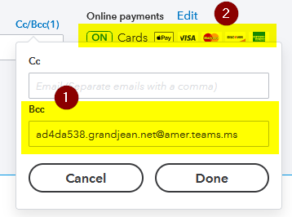
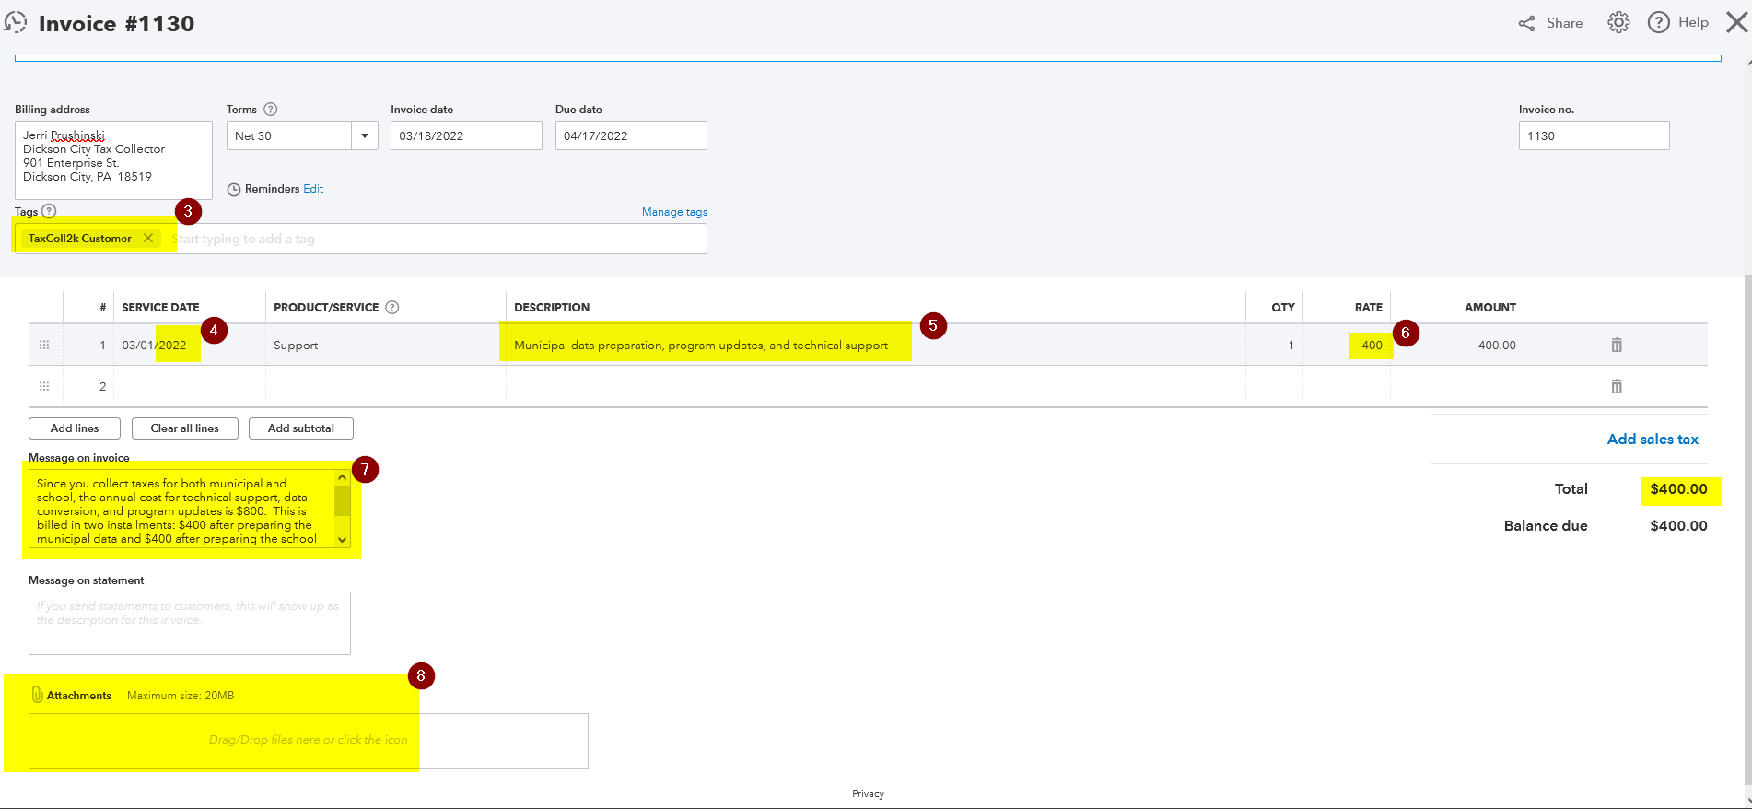

Billing for Muni-only Collectors
Tax collectors who collect municipal taxes only owe $500 per year (for 2022 - 2025 tax years).
When creating an invoice, check to make sure the following are set for these collectors:
- Email BCC: ad4da538.grandjean.net@amer.teams.ms
- Credit card payments: ON
- Tags: TaxColl2k Customer
- Service date: 3/1/{yyyy} Ensure this matches the current year
- Description: Municipal data preparation, program updates, and technical support
- Rate: $500
- Message on invoice: Since you only collect municipal taxes, the annual cost for technical support, data conversion, and program updates is $500. This rate is guaranteed through the end of your current term (2025 tax year).
- Attachments:
  - {None} during first two years of term
  - Pricing for upcoming term.pdf: during last two years of term


