Amending/Deleting (Un)Finalized Rebates

Amending a Finalized Rebate
Hypothetical scenario: A finalized rebate was sent to the taxing districts with correct rebate amounts enclosed;
however, it is now known that the rebate start date was incorrect. The property reassessment did not take effect
until February 15th, 2015, and not the submitted January 1st, 2015 date!
Let's amend the rebate we created to address this.
- Open the "Rebate Search Results Form."
- While the finalized rebate is selected, click the "Amend Rebate" button at the bottom of the form.
- The "Add Rebate" Form will appear with the selected rebate's values prefilled.
Notice how the "Original" land and improvement values are the "Corrected" values from before.
This is because we are currently rebating on a finalized rebate, so it enters the database
as an effective assessment.
We need to first revert our changes - if we were to change the start date to February 15,2015
at this point, our original values would be incorrect.
- Leave the "Start Date" as is and enter in the Original values that existed before the rebate was added ($31,700 in Land and $140,500 in Improvement)
- Finally, in the "Reason for Rebate," write "amending invalid rebate."
Your form should look like this:
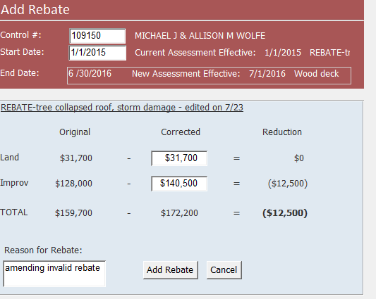

- Click "Add Rebate" and "Edit Rebate" will reappear.
- Fill in the same "Payment Periods" as you did last time. Click "Rebate Worksheet."
- The Rebate Worksheet should "refund" the rebate amounts that were calculated for the incorrect rebate period.
- Open the "Rebate Letter," verify that the values match from "Rebate Worksheet," close the report, then click
"Yes" on the print prompt. The "Edit Rebate" form should refresh and a "Letter Sent On: " date should appear.
- Exit "Edit Rebate."
- Open "Rebate Search Results" and verify that two finalized assessments exist:
  - the original invalid assessment
  - the most recent amended assessment. The most recent assessment if on the same day will exist as the official, effective assessment.
This activity has been lengthy and a little bit complicated, but hopefully these final steps clear up any confusion about the process:

Create New Rebate with Correct Start Date:
- Click "Add Rebate" on the "Rebate Search Results" form.
- Type in 109150 as the control number and 2/15/2015 as the start date, then press enter.
If your form looks like this, congrats!
You've amended the invalid rebate. Notice how the Original values are back to how they were before
we added the first rebate.
The message explains that a rebate was amended due to its invalidity. From here on out, you would do
the entire rebate process over now that we have reset the original values as of 1/1/2015, but instead,
you would use the start date of 2/15/2015.

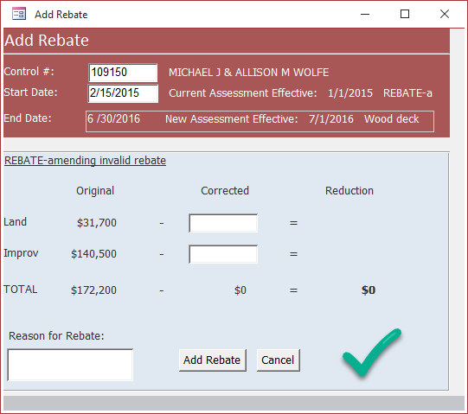

Deleting an Unfinalized Rebate
Deleting an unfinalized rebate is pretty straightforward. Let's walk through the process.
Create an Unfinalized Rebate:
- Open the "Rebate Search Results" form and click on the "Add Rebate" button.
- Once the "Add Rebate" form appears, enter a control number, start date, corrected values,
and rebate reason of your choice. Since the rebate is being deleted, the values of the parameters do not have
to hold any significance for the rebate being added.
- Click "Add Rebate" when ready:
- The "Edit Rebate" form will appear, but you can close out of it.
- Return to the "Rebate Search Results" form.
- Click the refresh button in the top-right corner to retrieve an accurate selection of created rebates.
- Upon refreshing, you should see your newly created, unfinalized rebate. We can tell it is
unfinalized due to a lack of a "Letter Sent On" date.

Delete the Unfinalized Rebate:
- Click once on the unfinalized rebate record so that it is selected.
- Look to the bottom of the "Rebate Search Results" form and notice that the third button's
caption has changed from "Amend Rebate" to "Delete Rebate."
In the "Rebates" feature, you can only delete unfinalized rebates and can only amend finalized rebates.
- Click on "Delete Rebate"
- A prompt should appear asking if you are certain that you would like to delete the record.
  - Pressing "No" returns no results.
- Press "Yes."
Congrats! The record is deleted and should be removed from the form records.

View/Edit Rebate: The Difference
Similar to the "Amend/Delete Rebate" button, the second button at the bottom of the
"Rebate Search Results" form changes caption based on if the rebate selected is finalized or not.
If a selected rebate is finalized: The button appears as "View Rebate"
- This is because the only way to change a finalized rebate is by amending it.
You may only View a finalized rebate.
- Clicking on "View Rebate" will open the "Edit Rebate" form where all the controls
are still locked and the "Letter Sent On: " has a date filled.
- Viewing any of the reports will not create a new finalized rebate. This is only
possible one time from an unfinalized rebate.

If a selected rebate is unfinalized: The button appears as "Edit Rebate"

Clicking "Edit Rebate" will open the "Edit Rebate" form and the controls will be unlocked.
You would click this button to finalize a rebate.
For a refresher on how to use the "Edit Rebate" form, refer to Editing a Rebate.

