Cost/Land Report
The Cost/Land Report was added in Version 22.12.30 of Assessor2k.

How to Use
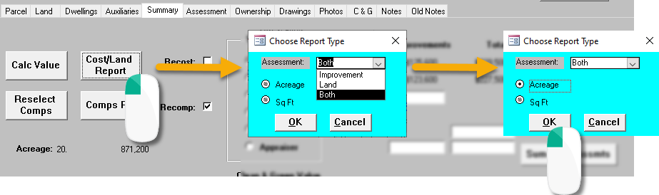
Click [Cost/Land Report] to open the blue box. You have the flexibility to generate:
- Improvement-only value breakdown
- Land-only value breakdown
- Both improvement and land value breakdowns
"Both" is the default "Assessment" selection.

In the spirit of the "Land" tab's Acreage breakdown, you can select either the "Acreage" or "Sq Ft" calculation. Your choice of measurement will display on "Land" or "Both" assessment reports where applicable. Note: these options are disabled if you've selected the "Improvement" assessment.

Report Generated with "Both" Assessment Option


