Assessor 2k User Support
General user support page for Assessor 2k

Requesting Assessor 2k User Support
When requesting support please include answers to the following questions:
- Which computer are you currently experiencing the issue on? (i.e., TaxRE110, TYL7626 and/or IP address)
  - If unsure, click the Start button and type "pc name" and select "View your PC name"
  - 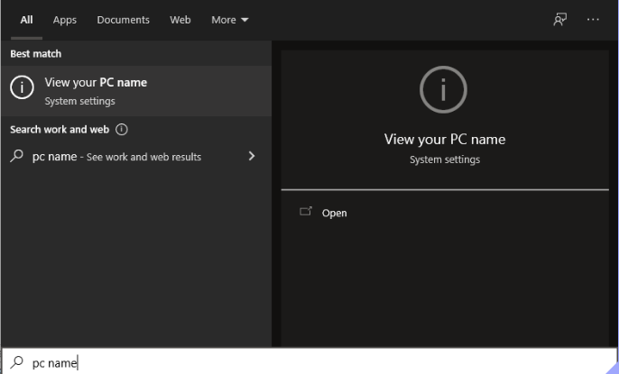
  - Find your computer name next to "Device Name" (My computer is named "hal"):
  - 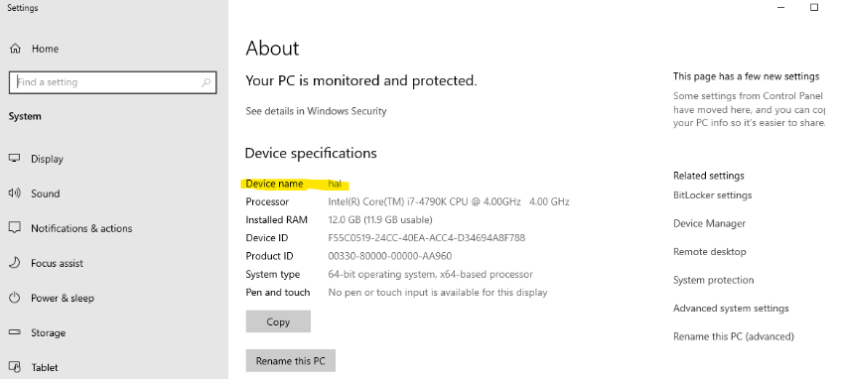
  - To find your IP address:
    - Click the Start button and go to Settings → Network & Internet
    - 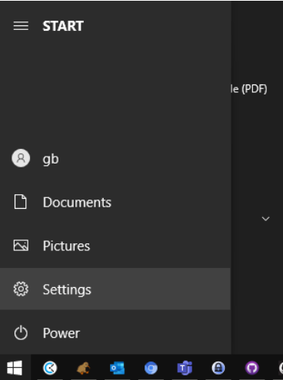
    - 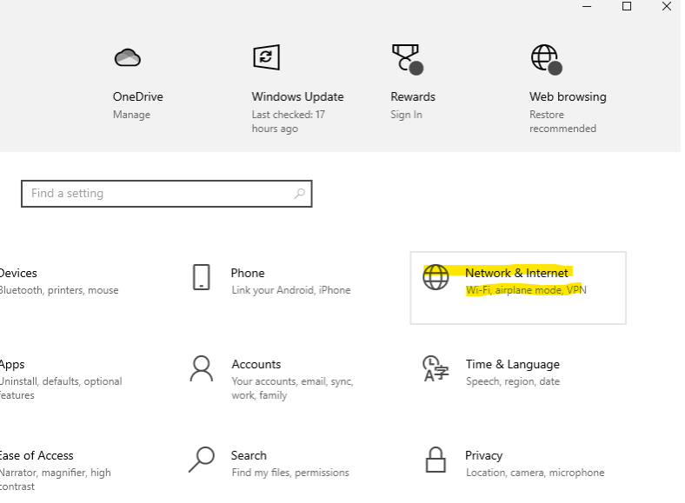
    - If connected via Ethernet, select Ethernet → Properties. If connected via WIFI select Wifi → Properties.
    - 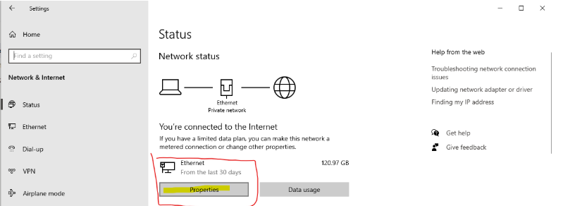
    - Scroll down to Properties and click the Copy button
    - 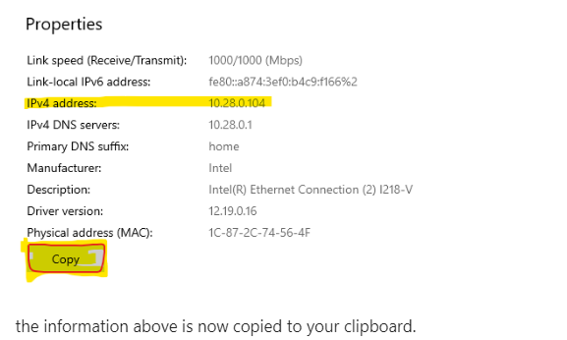
    - the information above is now copied to your clipboard.
    - Paste into your support request. The pasted text will look similar to this:
    - 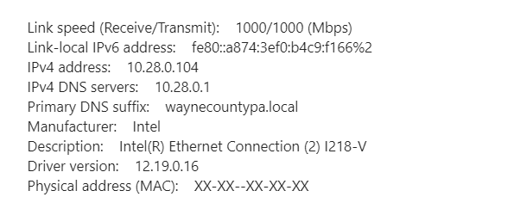
- Which user are you currently logged in as? (i.e., tylerre10)
  - If unsure, click the Start button, then hover over the "Person" icon:

Assessor 2k Tips

